***The graph below shows changes in young adult unemployment rates in England between 1993 and 2012.***

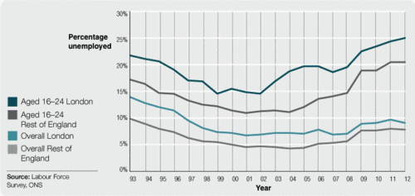

The line graph shows us the percentage of young people who live in England aged 16-24 which are unemployed from 1993 to 2012.

It is clear that London **registered** the highest rate of unemployment of young adults over the whole period given. It is also noticeable that the trend is similar for the all four categories mentioned between 1993 and 2012.

In 1993, the largest **proportion of unemployed** people aged 16-24 lived in London, about 22% respectively. There were around 17% of them in the rest of England. However, the overall unemployment rate in London and the rest of England was slightly lower, with figures of **just under** 15% and 10% respectively. Over the next 6 years, there was a decrease of approximately 5% in the unemployment rate **of each of the four categories.** Therefore, the figure for young people who lived in England and had no job reached its lowest point, with just under 15%.

By 2012, the unemployment rate of Londoners aged 16-24 **reached its peak, at 25%.** People of the **same category of age from the rest of England** also **reached the highest point**, at about 21%. By contrast, **there were only around 8% unemployed people** for each of the two regions, overall London and rest of England.

***The graph below shows changes in young adult unemployment rates in England between 1993 and 2012.***



The line graph illustrates changes in the number of people who were unemployed in England from 1993 to 2012

It is observed that the propotion of unemployed people experienced a similar trend over the period shown, while the line of the young at age from 16 to 24 in London underwent the most dramatic change. In 1993, the percentage of employed people started the highes point, around 23%, higher the number of the rest of england appoximately 7%. The figure of overall London and the rest of england just under lower, about 18% and 10% respectively. Over the next 6 years, all four categories fell dramatically, the percentage of employed people in England hit the low-point, about 15%, while the others lost about 5% each. However, after that, the figure of unemployed youngster in london rocketed and climb to the highest point at the end of period. Similar to the number of unemployed junveniles in the rest of england, around 20% in 2002. There were also a similar phenomenon to the number of unemployed individuals in overall London and the rest of england, two figures went up and down, and reached around 8% at the end of period.

***The graph below shows changes in young adult unemployment rates in England between 1993 and 2012.***



The line graph illustrates changes in the number of people who were employed from 1993 to 2012.

The chart registered a similar trend among all the lines, yet the percentage of people between 16 and 24 in London underwent the most dramatic change. In 1993, the number of employed in London started at around 23%, higher than the rate of the rest of England, about 7%. The figure of overall unemployed in London and rest of England just under lower, approximately 15%, 10% repectively. Over the next 9 year period, all four categories fell gradually, the number of 16-24 employed people reached its low-point in 1999. In 2012, two figures of employed youngster in London and the rest of England increase significantly and climbed each their peaks at the end of period, 25% and 20% respectively. Two other lines continued to decrease slowly, before growing sharely and bot hit around 8 % at the end of period.